
Source Code Management

Lab File
Slot: L25+L26

Submitted by:
Anuj Preetham
BTech CSE(AI&ML) 4th sem
A866175124032

Submitted to:
Ms. Manisha Nair
Assistant Professor
AIIT
Index

Sl. no. | Name of the Program | Date | Pg. no.
1

10/3/2026

1) Creating files using touch command and deleting using rm

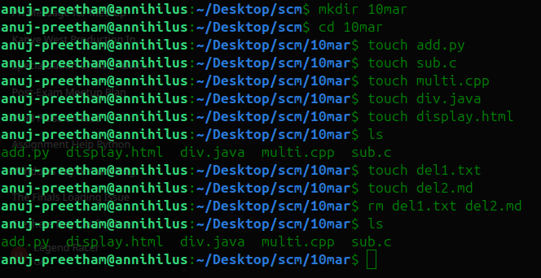

2) Creating folders using mkdir command and removing using rmdir

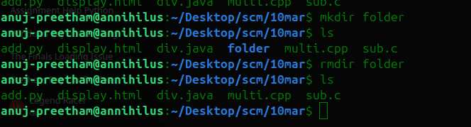

3) Deleting non-empty directories using rm -r command

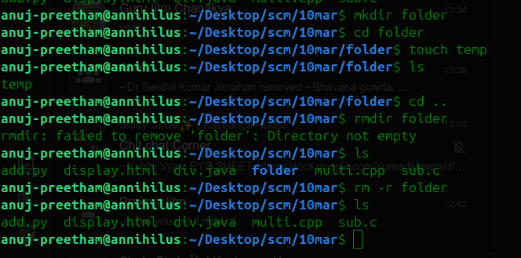

17/3/2026

4) Using cat to display file contents in terminal

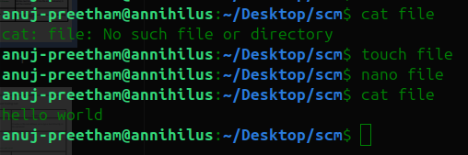

5) Writing text to a file using echo

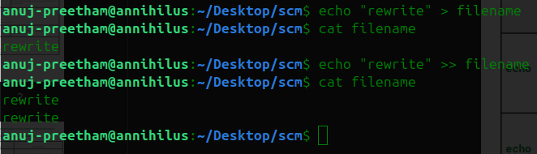

6) Writing text using cat
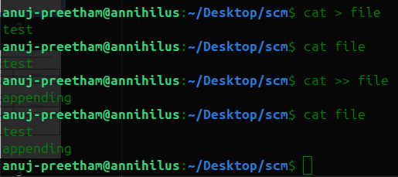

7) Copying contents from one file to another

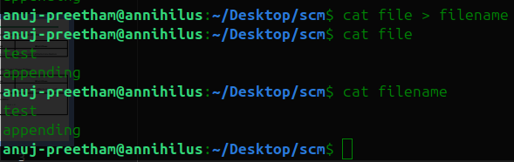

8) Editing a file using nano editor

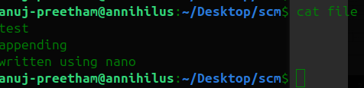

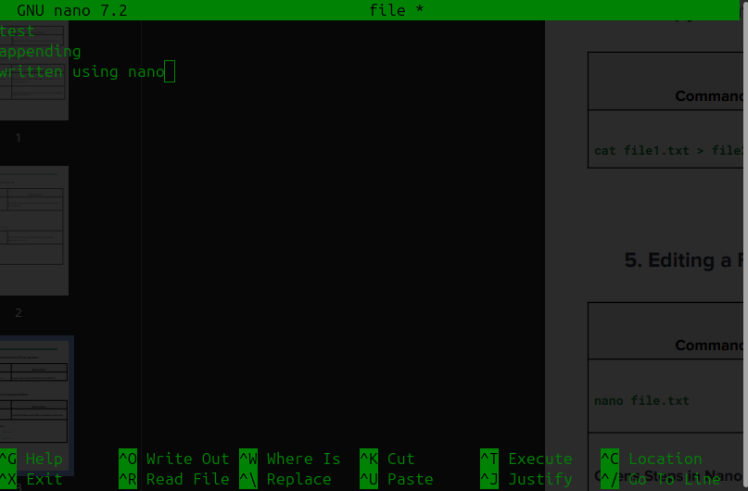

24/3/2026

9) File Creation using echo & cat

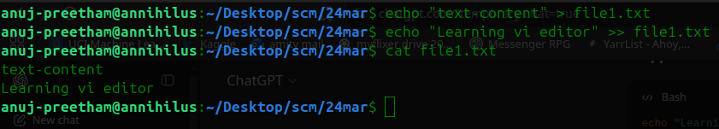
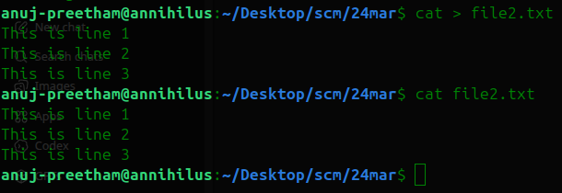

10) Copy Content Between Files

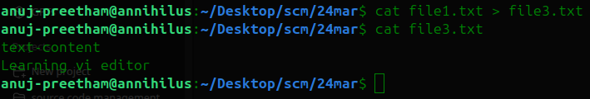

11) vi + Git Configuration
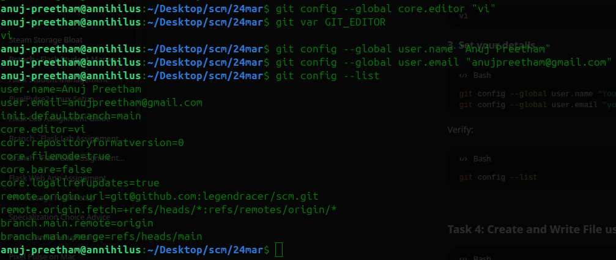

12) Create and Write File using vi

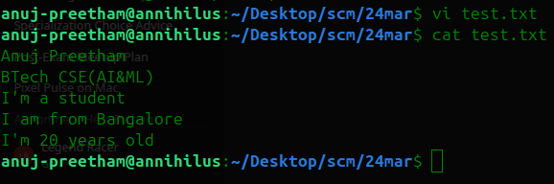

13) Editing Practice (Insert + Navigation)

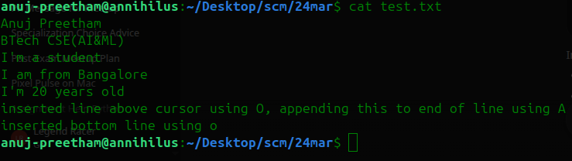
14) Delete Operations

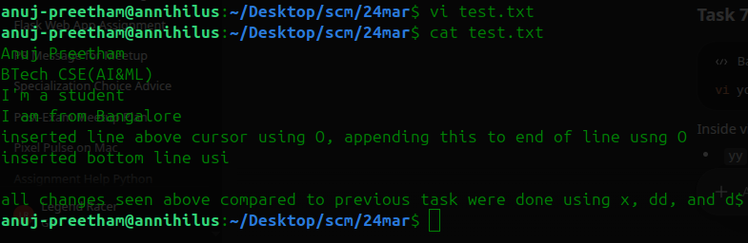

15) Copy-Paste in vi

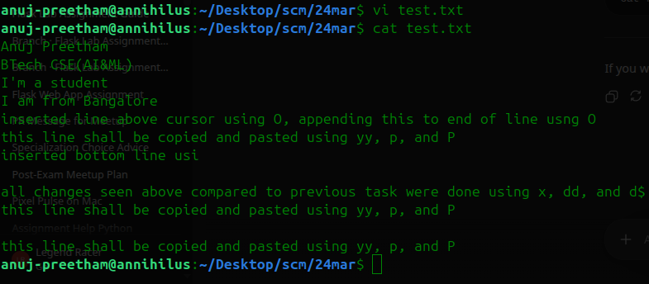

5/5/2026

16) Pushing local code to GitHub

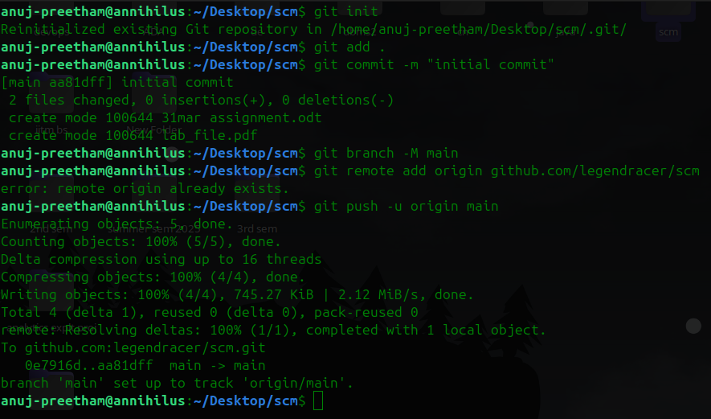

17) Pushing to another branch

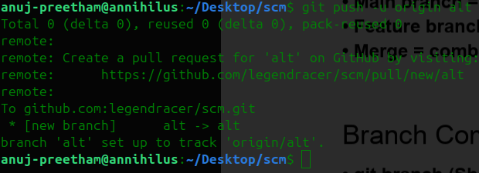

18) Branching commands

git branch (Show branches)
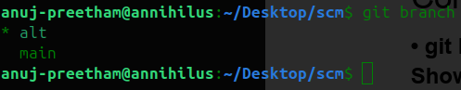
git branch branch_name (Create branch) & git checkout branch_name (Switch branch)
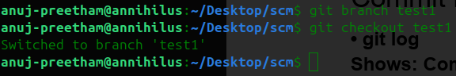
git checkout -b feature2 (Create + switch)
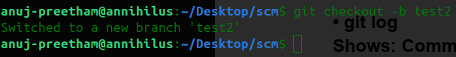
git merge branch_name (Merge changes into current branch)
git branch -d feature1 (Delete branch)
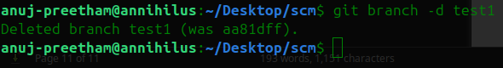

19) Commit History

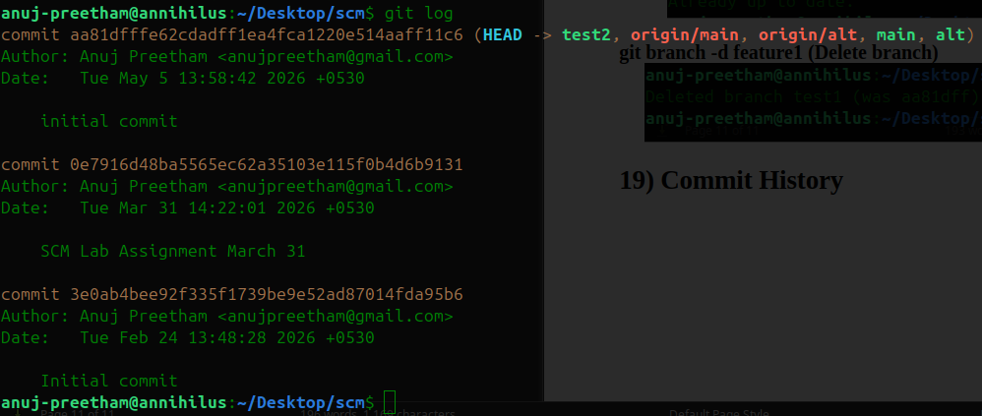
20) HEAD in Git

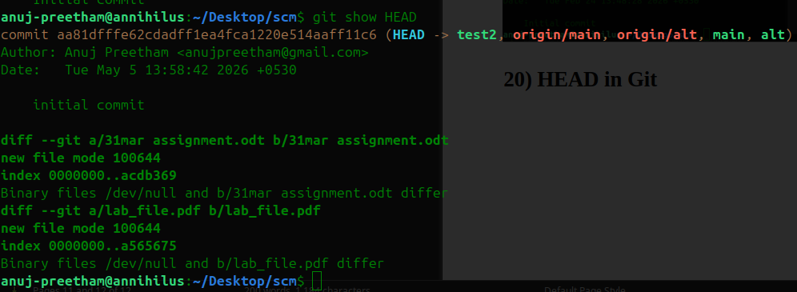

9/5/2026

1) Resolving merge conflict in greeting.py

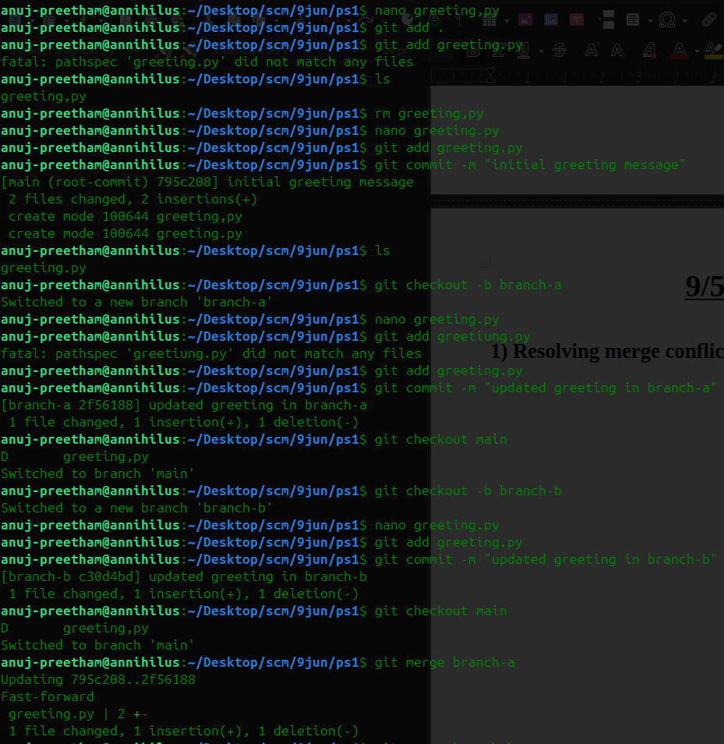

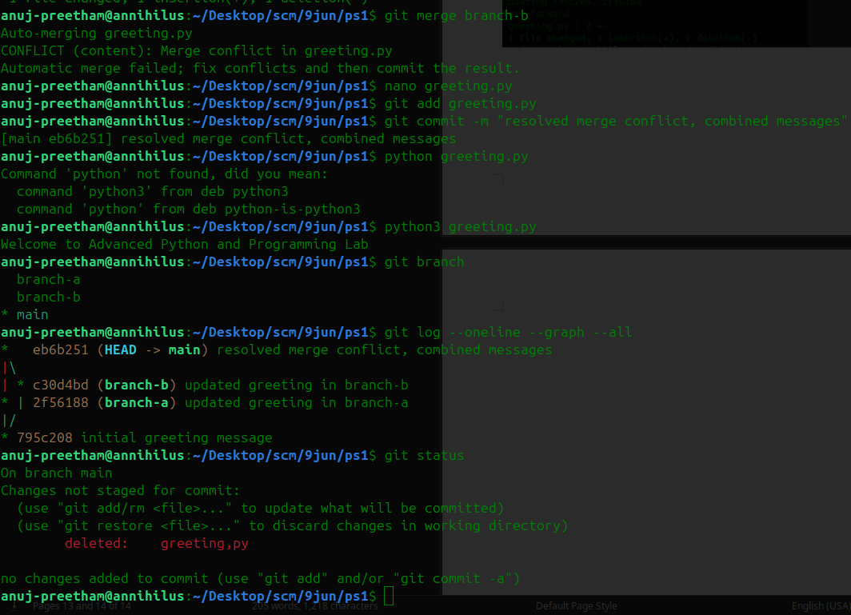
2) Resolving merge conflict in calculate.py

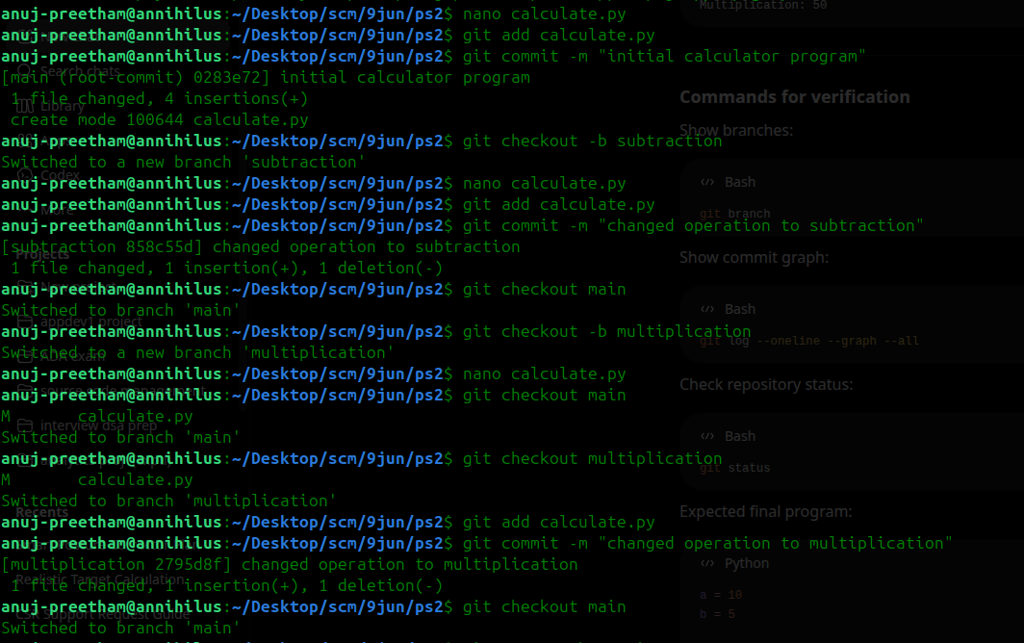
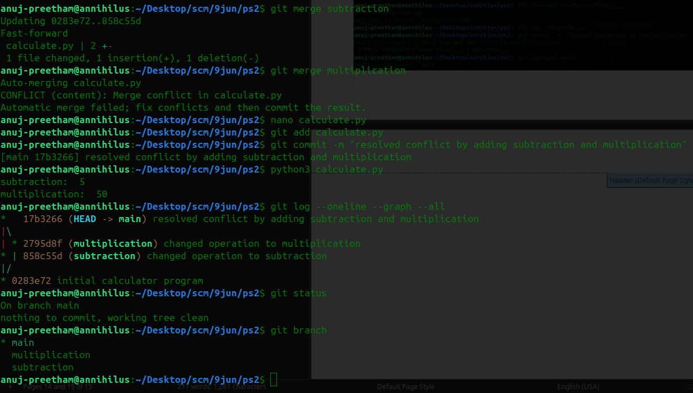
3) Resolving merge conflict in product.py

